

**School:** School of Information Technology

**Semester:** Semester 4

**Subject:** Deep Learning

**Topic:** CNN model mini project

**Submitted to:** Sunil Kumar

**Team Members:** Jiya Patel (212022008)

Shubh Viramgama (212022007)

Mit Makwna (222022001)

Bhaviyanshi Patel (212022073)

Yuvraaj Gajjar (212022006)

**TEXT CLASSIFICATION**

The mini project is a well structured and comprehensive for training a deep learning model for emotion classification using NLP

About the project:-

The model is designed for emotion classification based on text data. It takes in sentences as input and predicts one of four emotions : **anger, fear, joy, sadness.**

This code performs several tasks related to natural language processing (NLP) using deep learning techniques.

**LIBRARIES:**

The libraries are imported by necessary python libraries such as pandas, numpy, matplotlib, seaborn and Tensor/Keras modules for building and training neural networks

**DATASETS:**

The code loads 3 datasets : Training, Validation and Test sets from text files.

**MODEL ARCHITECTURE:**

The model uses embedding layer followed by 2 parallel branches with Convo1D layers, BatchNormalization, ReLU activation, Dropout and GlobalMaxPooling is appropriate for text classification tasks.

The use of concatenate to merge the branches and subsequent dense layers for classification is also well thought out.

**MODEL EVALUATION**:

The code evaluates the trained model on test data , computing various metrics like loss, accuracy, precision and recall.

It visualizes the training history using matplotlib , showing the training and validation loss, accuracy , precision and recall epochs.

**ACCURACY OF THE MODEL** :

* **TRAINING ACCURACY:** the accuracy is achieved on the training data.
* **VALIDATION ACCURACY:** the accuracy is achieved on the validation data.
* **TEST ACCURACY:** the accuracy is achieved on test data.

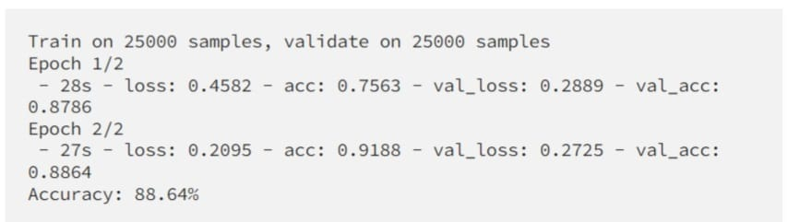

//(loss, accuracy, precision, recall) = model.evaluate([ts_x, ts_x], ts_y)

print(f'Loss: {round(loss, 2)}, Accuracy: {round(accuracy, 2)}, Precision: {round(precision, 2)}, Recall: {round(recall, 2)}')//

This code will print the loss, accuracy, precision and recall values of the model on the test data and also interpret the accuracy value to understand how well the model performs in classifying emotions.

Overall, this code demonstrates a complete pipeline for text classification using a convolutional neural network, including data preprocessing, model training, evaluation, and prediction.

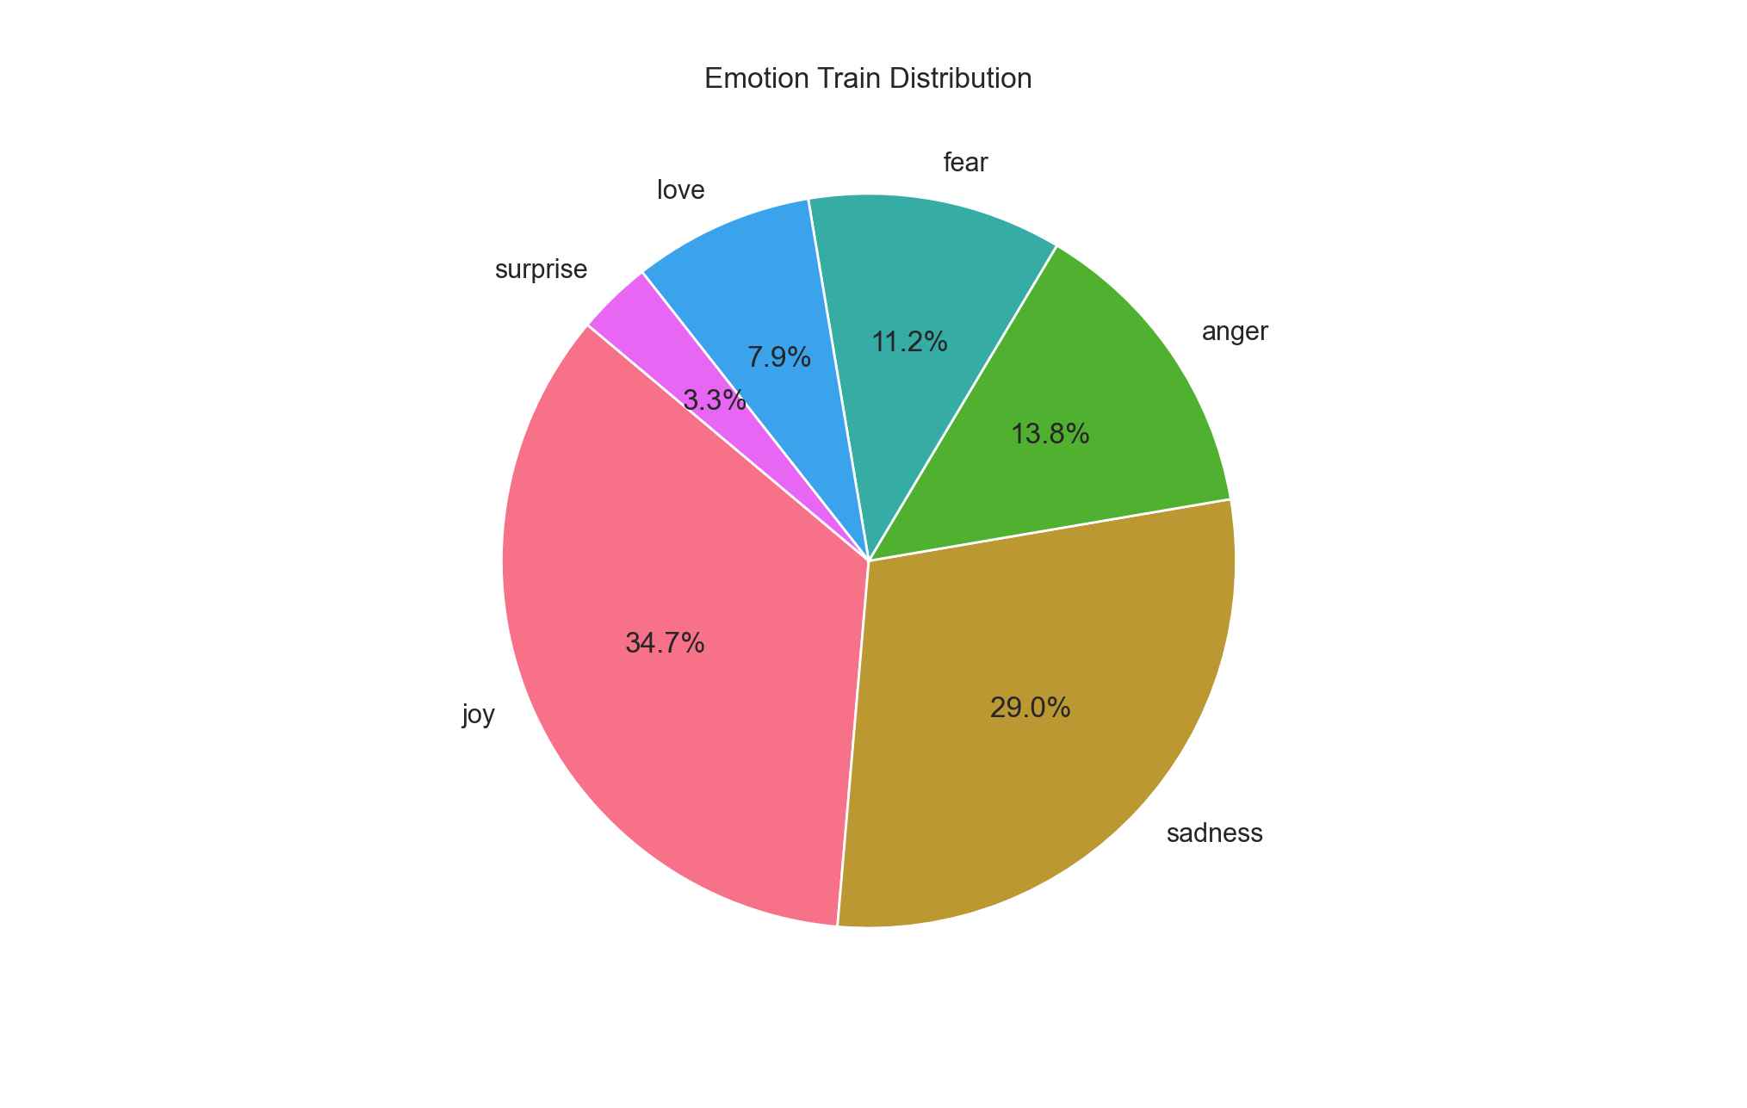

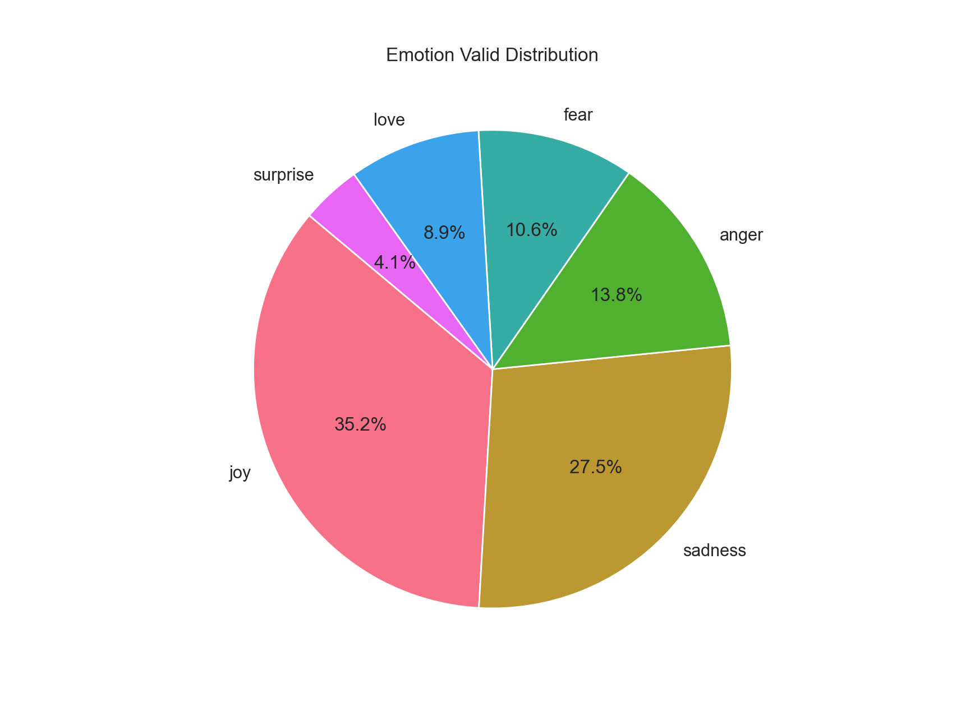

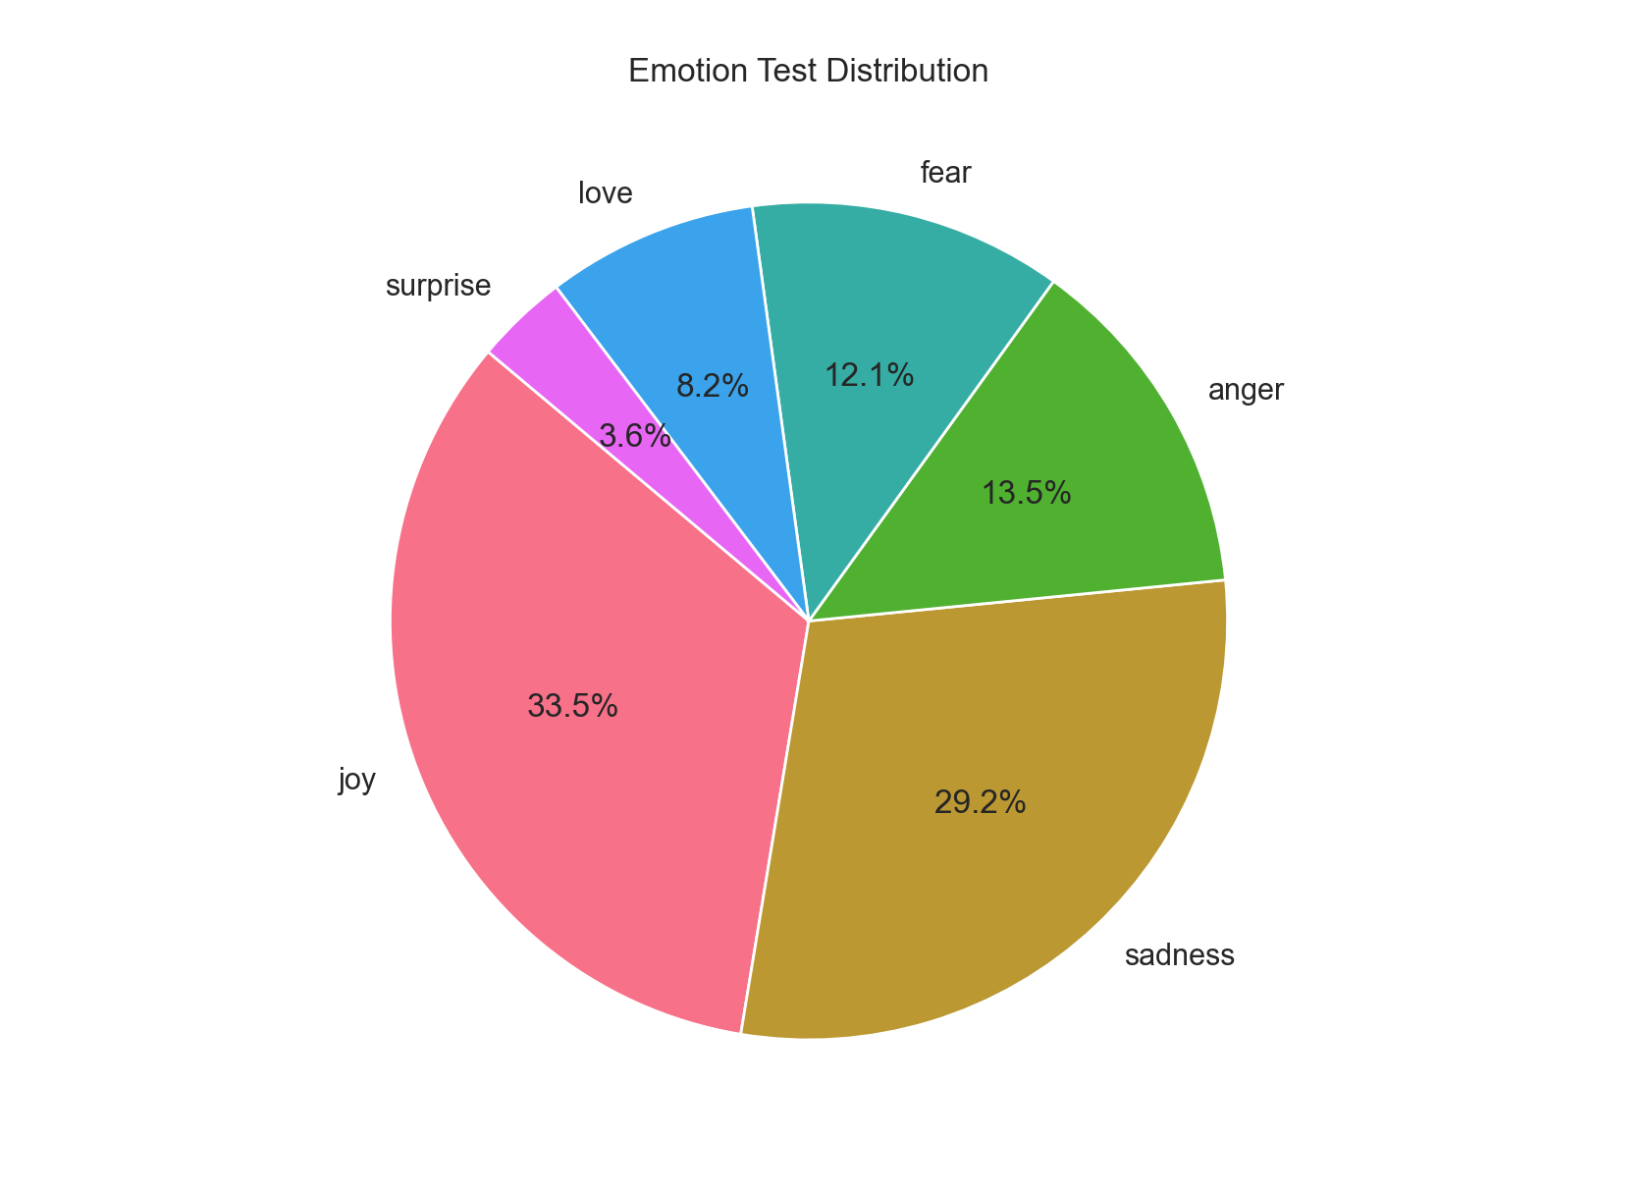

**REFERENCES**

GitHub

Kaggle : datasets

You tube

**THANK YOU**